How to use this form:
- This form is provided in Microsoft Word format so that you, as the fundraising organizer, can edit the form to meet your organization’s needs.
- You may wish to personalize the form by, for example, adding:
  - your organization’s name and/or logo, and
  - your organization’s contact information should your fundraising participants or customers have questions during the fundraising drive.
- If you have chosen not to sell all four products listed in the form, you can edit out those products you are not fundraising with to avoid confusion for participants or customers.
- You can set any selling price for the products. The prices shown in the form are examples only and are not recommendations by the manufacturer.
- To avoid later confusion, participants should be directed to fully complete each line of the form including full contact information for each customer, product quantities and total money collected. Participants should also be directed to get each customer’s signature confirming the customer’s order and money paid.
- After completing an order form, participants should tally the total quantities of each product and funds raised. They should also indicate a page number to keep track of how many forms they have completed.
- All the best for a successful fundraising effort!!!
 | NOAH MARTIN’S PRODUCT - FUNDRAISER ORDER FORM
Organization Name:_____________________  Organization Contact Name:_________________________  Organization’s Contact Information: ____________________________________________________________ |  | Mild Pepperoni Sticks - 600g |  | Hot Pepperoni Sticks - 600g |  | Honey Garlic Pepperoni - 600g |  | Turkey Pepperoni Sticks - 600g |  | Summer Sausage - 600g |  | 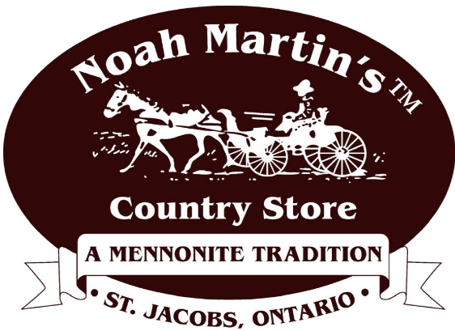
Price per Case |  | $23 |  | $23 |  | $23 |  | $26 |  | $15
Customer Name and Contact Information |  | Qty | $ | Qty | $ | Qty | $ | Qty | $ | Qty | $ | Total $ | Customer Signature
Total

Page # ___ OF ___

